**EXISTING SERVICES/ REST API:**

[**https://www.betafaceapi.com/wpa/**](https://www.betafaceapi.com/wpa/)

**Betaface API is a face detection and face recognition web service. It can scan uploaded image files or image URLs, find faces and analyze them. API also provides verification (faces comparison) and identification (faces search) services, as well able to maintain multiple user-defined recognition databases (namespaces).**

**This api helps us to estimate gender, age, ethnicity, emotion (smile/neutral) ,eyes, skin color, clothes and background colors etc.,**

**TESTING:**

|  |  |  |  |  |
| --- | --- | --- | --- | --- |
| **SNO** | **TEST CASE** | **DESCRIPTION** | **EXPECTED OUTCOME** | **RESULT** |
| **1** | To detect skin color | The API should detect skin color of given image | Api must work |  |
| 2 | To define bmi of a person | BMI of a person should be calculated based on height and weight of a person | Exact bmi of a person is calculated | success |

**Sample Code snippet of betaface api.**

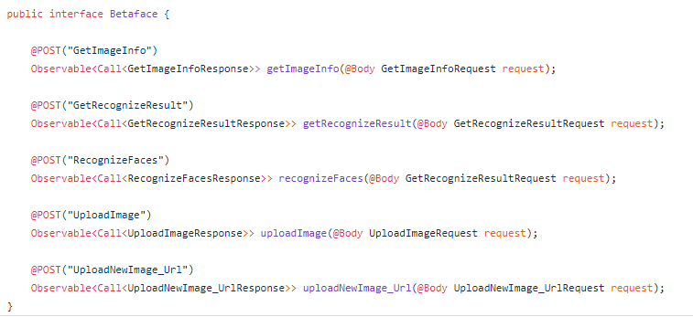

**Sample code snippet of BMI:**

**https://stackoverflow.com/questions/21698044/basic-bmi-calculator-html-javascript**

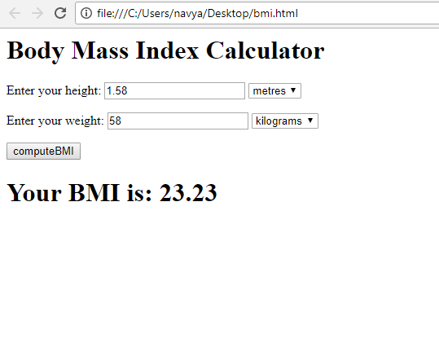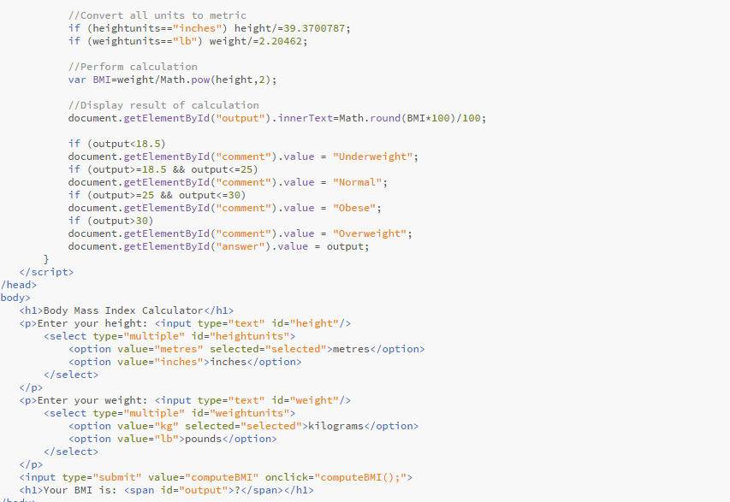

**output of bmi code:**